Monte Carlo Tree Search:
The application of Artificial Intelligence in board games.
Samuel Hardy
p13193068

Abstract
Monte Carlo Tree Search (MCTS) is an algorithm which simulates play and creates statistical success and failure. It then uses these statistics to decide what the best move of play is. This allows a greater depth of strategy then standard artificial intelligence.

Literature Review
  - Overview
The Monte Carlo Tree search (MCTS) is a Method for finding the best possible decisions; and building a search tree so that an artificial intelligence (AI) can follow the path with the highest reward. It acts by simulating multiple outcomes and calculating the best chance of winning from the ratio of visitation and rewards. MCTS is described as,
“A method for finding optimal decisions in a given domain by taking random samples in the decision space and building a search tree according to the results”[1].
MCTS is considered a general game programing AI. This is because of the lack of knowledge of what is needed for the algorithm to work; but it can be improved by having heuristic knowledge to bias the selection process. However not all games have heuristic knowledge, for example Go.
Go is a board game which has a high branching factor and before 2006 it was considered an incredibly difficult game to create an AI for. It is suggested that,
“Go is one of the few classic games for which human players are so far ahead of computer players”[1].
However, the addition of MCTS to Go has created a simple way for a computer to close the gap between human and artificial capability.
The goal of the game is to gain the most territory; this is by no means a simple matter and the fact that some AI have recently beaten adept human players at Go is incredible. As the game is not determined by simple rules which can be shown heuristically. It has been explained that Go has,
“A high branching factor, a deep tree, and lacks any known reliable heuristic value function for nonterminal board positions” [1].
Therefore the accomplishment of this mammoth task of incorporating MCTS into Go; has generated a lot of interest and creativity amongst game designers to expand the method so that it fits into other games.
“Spurred on by some prolific achievements in the challenging task of computer game Go, researchers are now in the process of attaining a better understanding of when and why MCTS succeeds and fails, and of extending and refining the basic algorithm. These developments are greatly increasing the range of games and other decision applications for which MCTS is a tool of choice, and pushing its performance to ever higher levels”[1].
MCTS is an increasingly popular way to achieve an AI which can have little to no knowledge of the game itself and still outperform heuristically driven AI. This is why it is important to bring MCTS to more simple games without the incredibly high branching factor. In order for the method to perform at its peak.

It is considered that, “Go is now competitive with the very best human players on small boards, though MCTS falls far short of their level on the standard 19x19 board.”[1].

This suggests that when the board is increased in size the branching factor becomes too high for the algorithm to cope; even with many optimisations and increased computer processing.
A game like Checkers is similar to Go but has a smaller branching factor, as well as being heuristically sound with many other AI techniques. Utilising checkers will allow me to compare MCTS performance in this way.

  - The MCTS Algorithms
In order to do this it is essential to become familiar with the four principles in MCTS; selection, expansion, simulation and backpropagation.
The selection process starts at the root node and finds the most urgent node which is nonterminal and has not been used in a previous recursion [1].
The expansion process adds a child node to the previous selected node according to the available moves [1].
The simulation process runs from the previous child node added though a predetermined default policy. This policy can be customised but is normally chosen randomly for the AI and Player until it reaches a terminal state [1].
The reward is calculated by a type of terminal state which is set by the programmer. If a winning condition is found for the Ai then the reward would be greater than if the condition was a loss, for simple games with few terminal state then 0 for a loss and 1 for a victory is generally used..[1]
Backpropagation takes the result of the simulation which is then taken up the tree back up to the tree and updates the notes visits and win value. If it is a loss it won’t add anything [1].
The algorithm then determines the best child or best move by the amount of wins or rewards gained against the amount of times visited. There are many ways to access the best child.
“Algorithm 1: General MCTS approach
function MCTSSEARCH(s0)
create root node v0 with state s0
while within computational budget do
v1 <- TREEPOLICY(v0)
<- DEFAULTPOLICY(s(v1))
BACKUP(v1, )
return a(BESTCHILD (v0))
TREEPOLICY: Select or create a leaf node from the nodes
already contained within the search tree (selection and expansion).
Default policy: Play out the domain from a given nonterminal
state to produce a value estimate (simulation)”[1].
Each node of the tree represents an action and the weight of the action, the heavier the weight the higher possibility of being chosen in later iterations. The tree policy first checks if the parent has the maximum number of children; with no potential moves left, it then uses the weight of the nodes to calculate the next best child. This will find the next non-terminal parent ready for expansion.
The parent which is ready for expansion will have a set of possible actions. The current system chooses one of these actions at random; adds a child node and selects this node ready for simulation.
Once the node has been selected the default policy will find a terminal state and calculate the reward from this terminal state. The default policy does not add nodes to the tree; but does find a terminal state by randomly receiving actions. A value is then calculated from this state for backpropagation.
Backpropagation starts at the node which was simulated using the default policy and updates the nodes statistics; which influences the decisions of the child selection policy. The statistics are updated to all the parents of the simulated node.
The algorithm involves building a tree until a set amount of iterations are completed or time is elapsed; at which point the search is completed and the best child of the root node will be returned. To calculate the best child; the nodes need to be assessed and compared, one of the most common approaches to achieve this is the most visited child.

  - Related Algorithms
  - A*
A* finds the best path using the given weights on the nodes; this is commonly used method for pathfinding. A* needs to be able to estimate the weight of each node. This is a big issue since a lot of games have hidden data; making A* unfeasible since it cannot predict the weight of future nodes. However, it is the simplest and quickest way of finding the best value. A* has been used in games like Mario so that an AI can replace a human player; this was so successful that it was deemed the solution to the Mario problem in the Ai Mario Championship in 2012.
  - Minimax
Minimax traverses an entire game tree using depth first search (DFS). DFS follows the children marking them as visited; once it gets to a terminal node it will backpropagate to the next non terminal node which is repeated for the entire tree. The algorithm attempts to maximise your potential victory while minimising their chance of victory. This is good but as the tree branches out the search has to traverse the entire tree; making it unfeasible for high branching games. It does however, produce very good results which are often unbeatable. This is because of the nature of the program iterating through the entire tree to get a guaranteed best solution. The best solution however, may not be the best move. Top chess players often don’t make the best move but attempt to make the other player make a worse move.
  - Alpha Beta Pruning
Alpha-Beata pruning is a search algorithm which prunes branches to decrease the number of nodes the minimax algorithm has to evaluate. This is an adaption of minimax but prunes potential branches to reduce the performance overhead. This is done by comparing the weighted values with a maximum and minimum.
if beta ≤ alpha : break [5]
return alpha;[5]
if beta ≤ alpha: break [5]
return beta;[5]
Alpha is the maximum of the current alpha and the score; while beta is the minimum of the beta and the score. The process simply cuts the branch if the minimum is greater than the maximum. “In maximizing nodes we are improving lower estimate (alpha) of the minimax value and in minimizing nodes the upper estimate (beta).”[5] . This shows the best approximate of the node. “we say we pruned/cut-off the search in node”[5]. The search is cut short and not wasted.
Alpha-Beta pruning has different strengths compared to MCTS, it is capable in strong heuristic and low branching environments like chess where it can beat MCTS [5]. However, in a more general low heuristic environment like Go alpha-beta pruning dose not cope with the high branching factor and low pruning capability due to the lack of heuristic values [5].

  - Exploration Vs Exploitation
Exploration versus exploitation is one of several problems with MCTS selection and expansion of nodes in which it should choose to expand and sample. The decision is whether to pick the highest possible reward exploitation or explore other nodes; which may have even greater hidden rewards. One option is to just set a constant k for the highest reward and randomly generate to see if another node is better, this is known as “greedy Monte Carlo selection” [1].
  - UCB1
A fast and simple method is needed to find the upper confidence bounds (UCB), these bounds estimate the possible reward of a given action.
“Lai and Robbins made use of upper confidence indices, which allow the policy to estimate the expected reward of a specific bandit once its index is computed. However, these indices were difficult to compute” [1].
There is a need to optimise the process of estimating UCB in order to potentially resolve the exploration vs exploitation problem.
UCB1 was introduced by Auer [3] whose policy was simple and easy to compute,
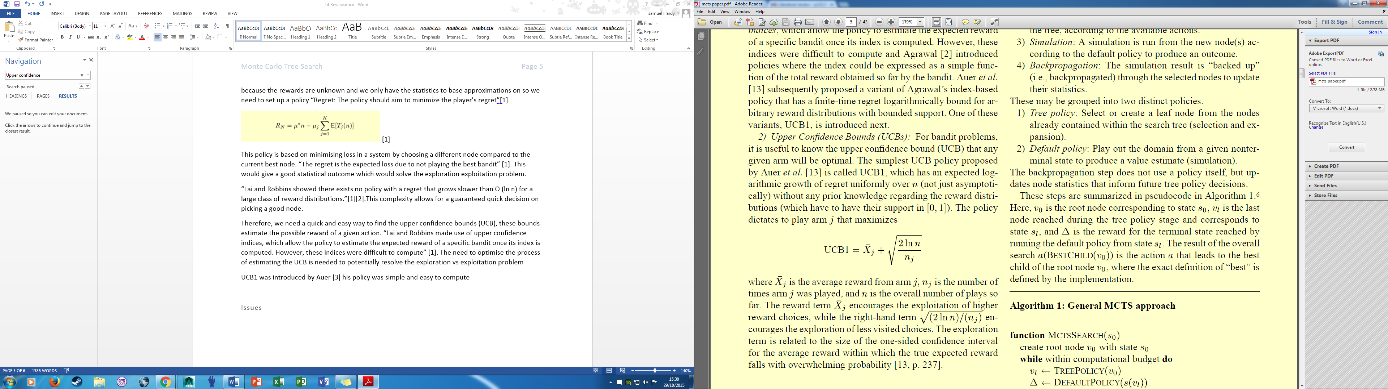[1]
“where Xj is the average reward from arm J, nj is the number of times j arm was played, and n is the overall number of plays so far“ [1].

UCB1 can be easily computed from the nodes to get the UCB indices therefore it is a good optimisation method for MCTS, as previously asserted it has a possible maximum complexity of O (ln n). This guarantee makes UCB1 a very promising candidate as well because;

“UCB1 has some promising properties: it is very simple and efficient and guaranteed to be within a constant factor of the best possible bound on the growth of regret” [1].

Therefore, it is no surprise that the combination of UCB1 and MCTS led to the most popular algorithm Upper Confidence Bounds for Trees (UCT).

  - UCT
The most popular option is using the Upper Confidence Bounds for trees (UCT) [1]. This uses the multi armed bandit model for the states. Multi armed bandit tries to minimise regret in a given situation. An illustration of this would be if a person was using a slot machine they would have to decide whether to carry on exploiting their current machine; or try and explore new machines in order to maximise reward. This is difficult because the rewards are unknown; and there are only the statistics to base the approximations on. So it is necessary to set up a policy;
“Regret: The policy should aim to minimize the player’s regret”[1].
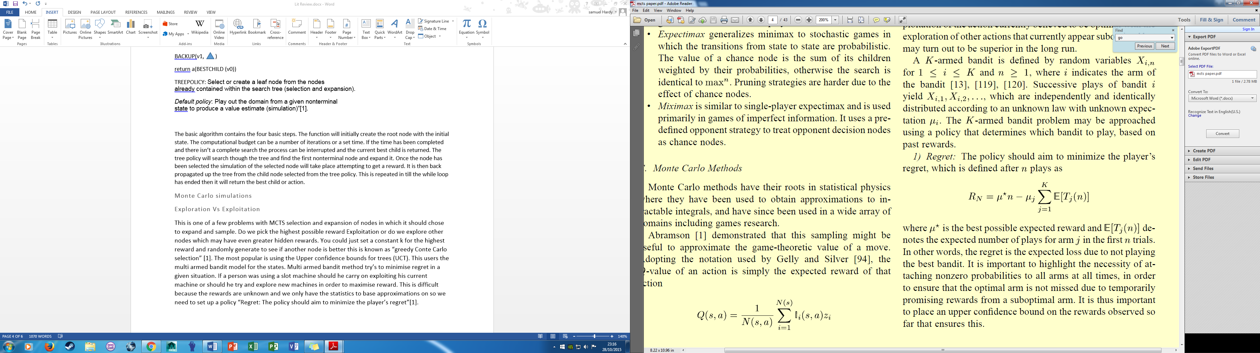[1]
This policy is based on minimising loss in a system by choosing a different node compared to the current best node. “The regret is the expected loss due to not playing the best bandit” [1].
This would give a good statistical outcome which would solve the exploration exploitation problem.
“Lai and Robbins showed there exists no policy with a regret that grows slower than O (ln n) for a large class of reward distributions.”[1][2].
This complexity allows for a guaranteed fast decision on choosing a good node.
Fig. 1. One iteration of the general MCTS approach. [1]

The importance of the UCT in tree policy can be seen in fig. 1 as it determines where the simulation will take place and it is necessary to be able to do this accurately and efficiently to select the best nodes. UCT replaces the basic Tree policy with;
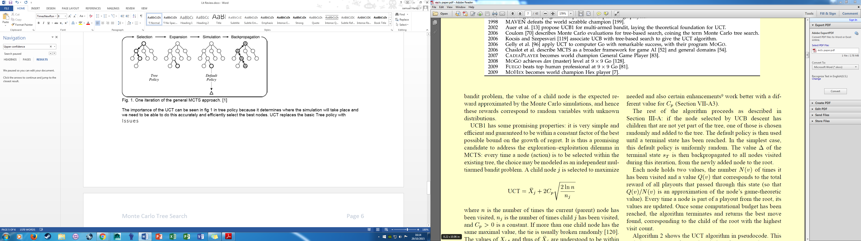[1]
Similarities can be seen between this and UCB1, the only addition is the exploration term Cp. The exploration term is a constant which can be adjusted to suit the system by increasing or decreasing exploration. UCT also makes it possible for all the children to be simulated; compared to UCB1 where some children may be missed.

“As each node is visited, the denominator of the exploration term increases, which decreases its contribution. On the other hand, if another child of the parent node is visited, the numerator increases and hence the exploration values of unvisited siblings increase” [1].

This ensures that a potential action will always have the possibility of being simulated so that regret can be minimised.

  - Issues
UCT is by far the most popular variation of MCTS but it is not the best selection process, UCB1 – Tuned
“It should be noted that Auer et al. were unable to prove a regret bound for UCB1-tuned, but found it performed better than UCB1 in their experiments” [1].

However, there was a sacrifice in speed meaning less simulations could be run in the given computational time, meaning the statistics wouldn’t be as reliable.
“UCT is considerably quicker” [1].

However, in other situations it may be found that a different variant UCB1 has a performance increase.

There is still much to discover in MCTS systems and many optimisations and adjustments of constants to make. This is because the field of research is still new.
“A primary weakness of MCTS, shared by most search heuristics, is that the dynamics of search are not yet fully understood” [1]

While the enhancements help and increase performance; it could still be increased by changing a constant or by using a different algorithm. There is not much help in deciding which is best in a very specific problem.

“the dynamics of search are not yet fully understood”[1]

Therefore, before the enhancements and constants are set; the very basic algorithm is unpredictable and unknown as well as the definition and methods being different;

“A problem for any fast-growing research community is the need to unify definitions,
methods, and terminology across a wide research field”[1].

There is a need to collaborate findings and unifying progress so that there is a generality between peers.

  - Applications
  - High branching games
As previously discussed the application of MCTS in Go is the current most popular development, since it is new territory.

“Go has become the new benchmark for AI in games”[1].

Therefore, it is natural for most people to test new and current ideas for Go. There has been some success in decreasing the branching factor by

“reducing the number of available actions at any moment in time”[1].

By simplifying the game; the branching of decisions get brought under control but this does not solve the problem since humans would want to play the full game even against AI, but it does have the ability to win. However, this reduces the playing ability of the AI.

In reviewing the introduction of MCTS Browne et.al suggests, “The authors conclude that MCTS is a promising approach: despite the lack of domain-specific
knowledge, the algorithm outperformed baseline and human players across 12 scenarios” [1].

However, A Real Time Strategy (RTS) game does not have much in common with Go in terms of actual game play but has a similar problem

“branching factor of the decision trees in such games may be unlimited” [1].

This shows that a different approach would be needed to compensate the even higher branching problem.

This shows that there is a similar correlation in research. Researchers in Go cannot cope with a 19x19 board and researchers in RTS cannot cope with the high branching factor of certain games. This is because the algorithm cannot perform quickly enough in the computational time to explore and expand enough nodes. Therefore, MCTS is restricted by the amount a game branches out.

  - GGPs

General game players (GGPs) use the dynamic approach of MCTS to allow a singular algorithm to be able to play multiple games with very little to no domain knowledge.

“GGPs must find good solutions to a range of previously unseen problems” [1].

This approach was first tested in 2007 by Hilmar Finnsson [4] using MCTS with very little enhancements,

“They demonstrate the clear superiority of their UCT approach over flat MC” [1].

Monte Carlo the original approach to GGPs became obsolete and research began to further enhance MCTS.

  - Discussion
Game AI must be challenging but beatable by a human player for the game to be fun. MCTS uses random moves to create the statistics; this allows error to be created from the algorithm. This makes it appear like a mistake has been made as if you were playing against a human player. I believe that this is one of the greatest strengths of MCTS over all other graph search functions. To get this effect however it would need to be tuned towards an individual’s ability to play the game.

Tuning MCTS towards a game can be difficult since there has been little application so trial and error with the many optimisations available for each policy. There is also the ability to edit MCTS potential budget this can give very different results. An issue with optimising using game knowledge is that the Monte Carlo system loses its generality.

MCTS also is capable of being reused in many games because it does not require any tactical or strategical knowledge of the game; all it needs is a list of possible moves to get to the next state and a definition of a terminal state. Therefore, it has the ability to be reused in multiple games with very little modification.

MCTS is likely to be improved and changed over the coming years to fit multiple AI problems. RTS could be one of these because of its ability to simulate strategy by not always taking the same path to achieve a similar goal. MCTS also rarely starts the same creating a dynamic AI; without having to code any extras.
The biggest problem is the almost infinite outcomes a RTS game can implement.
MCTS will improve greatly when it has the ability to prune its branches like alpha beta pruning; this would solve the problem of high branching games. The current issue is that the node selection is random and non-uniform so the true value of each node is unknown.
Implementing MCTS in simple board games shows how effective the algorithm is. This is due to the simplicity of the game and essentially does a minimax and Monte Carlo search, if the computational budget is high. Since it completes the game tree and simulate the best nodes. This can lead to an impossible to beat AI which for competitions and systems is good but for most applications against players; can lead to frustrating scenarios.
Modern computer games want an AI with a dynamically changing difficulty and computational budget whilst never coming up with the same solution. An example of this would be the AI in Left 4 Dead where it decides the placement of items and enemies to try and defeat the player. This would be similar to a strategy game for the AI and since players can be unpredictable a dynamic reward system with MCTS could be a solution. Being able to stop MCTS half way through its process allows leniency and prioritisation of the CPU budget. If there is an increase in game physics and rendering which is prioritised higher than the AI; then it can be interrupted at any time. This will however, decrease the potential but allow the player to carry on without being interrupted with frame stutter.
MCTS searches the tree in a way that can allow what seem like early mistakes but lead to a winning move later on which other graph searches may have pruned or ignored. This gives MCTS an in depth strategy of future good moves from an initial bad move.

Bibliography
  - [1] Cameron B. Browne, Edward Powley, Daniel Whitehouse, SimonM.Lucas, Peter I. Cowling, Philipp Rohlfshagen, Stephen Tavener, Diego Perez, Spyridon Samothrakis, and Simon Colton.
  - “A Survey of Monte Carlo Tree Search Methods”, pg 1 - 47
  - [2] *T. L. Lai and H. Robbins, “Asymptotically efficient adaptive allocation
  - rules,” Adv. Appl. Math., vol. 6, pp. 4–22, 1985.
  - [3] P. Auer, N. Cesa-Bianchi, and P. Fischer, “Finite-time analysis of the
  - multiarmed bandit problem,” Mach. Learn., vol. 47, no. 2, pp. 235–256,
  - 2002.
  - [4] H. Finnsson, “CADIA-Player: A general game playing agent,” M.S.
  - thesis, Schl. Comput. Sci., Reykjavik Univ., Reykjavik, Iceland, Mar.
  - 2007.
  - [5] T. Jakl “Arimaa challenge – comparission study of MCTS versus alpha-beta methods” Bsc thesis Comput. Sci, Charles University, Prague , Aug

Path Is a route though a graph.
A node without children
A state with no children and no possible moves
The game boards current condition.
A possible move that the player or Ai can make in the game.
A static value

